Convolutional Neural Networks (CNN)

Convolutional Neural Networks (CNNs) are a type of deep neural network specifically designed for processing and analyzing structured grid-like images. Due to their ability in identifying spatial patterns, CNNs are a powerful tool for image classification tasks. They automatically detect important features in images, like edges and textures, which form the basis for more complex patterns at deeper layers [1].

Why CNN?
CNNs are known for their effectiveness in handling image data and automatically learning spatial hierarchies [2]. Traditional machine learning algorithms would require manual feature extraction, which can be error-prone and may not capture important patterns in complex data such as ECG images.
- Accuracy: CNNs outperform other algorithms on image classification tasks due to their ability to learn complex patterns.
- Automatic Feature Extraction: CNNs do not require handcrafted features, which may be limited. This is especially useful for medical images like ECG, where subtle variations are critical.
- Efficiency: CNNs require fewer parameters, making them computationally efficient for image-based tasks.

Algorithm
The CNN architecture used for this ECG classification consists of the following components:
- Input Layer: Grayscale ECG images resized to 128x128 pixels and normalized
- Convolutional Layers: Three convolutional layers with 32, 64, and 128 filters of size (3x3), each followed by Batch Normalization, ReLU activation and max pooling (2x2). These layers detect and retain essential features of the ECG images.
- Flattening Layer: Flattens the 2D matrix from the convolutional layers to a 1D vector, allowing data to pass to the dense layers
- Dense Layers: The flattened layer is passed through a dense layer with 128 neurons, using ReLU activation to introduce non-linearity. The final dense layer has 4 neurons (corresponding to the four classes) with Softmax activation.
- Optimization: The model is compiled with the Adam optimizer and uses categorical cross-entropy loss due to the multi-class classification.

Implementation
The implementation consists of several key stages:
- Data Loading and Preprocessing: ECG images are loaded, converted to grayscale, resized to 128x128 pixels, normalized. Data augmentation is applied using ImageDataGenerator, which performs random rotations, zooms, shifts, and flips on the training images. Labels are one-hot encoded to represent the four classes.
- Model Definition: The CNN model is created using TensorFlow and Keras, following the architecture described above.
- Training the Model: The model was trained on the pre-processed dataset for 100 epochs (with Early Stopping) with a batch size of 32. The training was halted at 39 epochs due to early stopping callback, which monitored validation accuracy with a patience of 5 epochs.
- Evaluation: The model’s accuracy and loss were tracked over epochs. The model was also evaluated on test data to ensure it generalized well to unseen data.
- Visualization: Training and validation accuracy and loss were plotted, and a confusion matrix was created to visualize the model’s performance across each class, along with a classification report. ROC curves were also plotted along with the AUC values.

Results and Analysis
- Performance: The model achieved an overall test accuracy of 84.49% as shown in Figure 1, indicating solid performance in classifying ECG images into the four categories.

- Training and Validation Metrics: To track model performance during training, the validation accuracy and loss was plotted as shown in Figure.
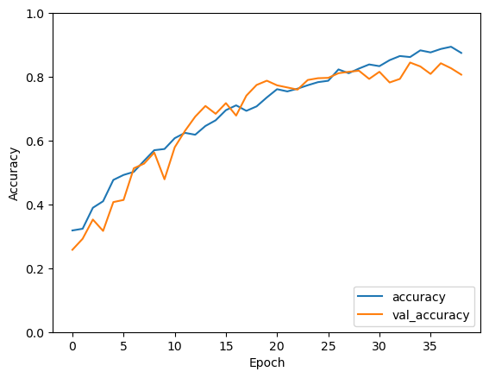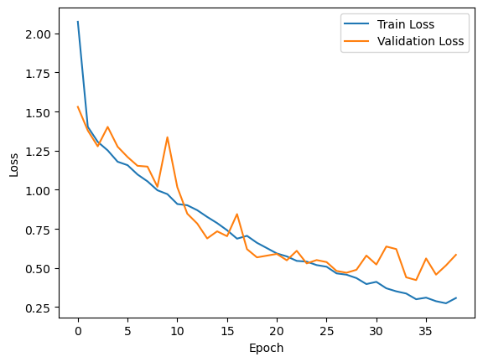

- Classification Metrics: The classification report shows good precision, recall and F1-scores for most classes, as shown in Figure 2. The “History of MI” class shows slightly lower recall, indicating room for further improvement.
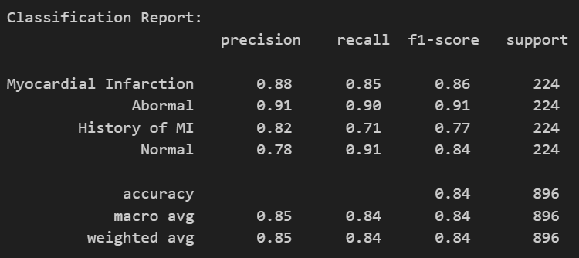

- Confusion Matrix Analysis: The confusion matrix confirms that the model has good performance across all categories, with few false positives or false negatives as shown in Figure.
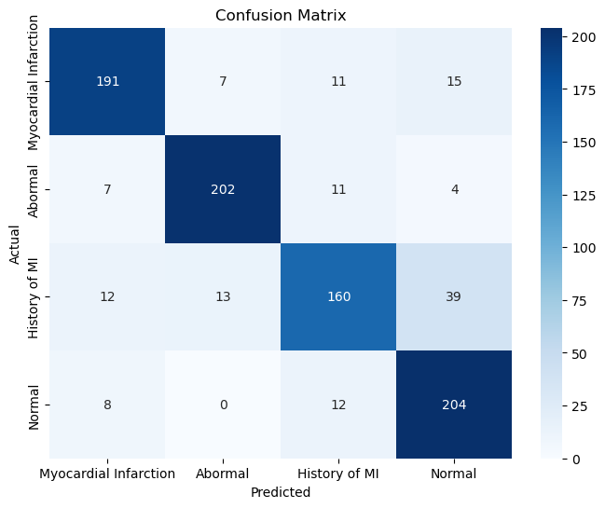

- ROC Curve and AUC Analysis: Further the ROC curve was plotted for each class and the AUC values were computed. The AUC values for each class as shown in Figure indicate that the model fairly distinguishes between each ECG category.
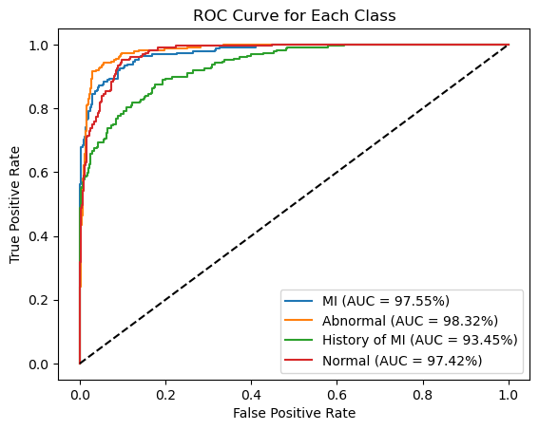

- Overfitting and Generalization: The model showed a reasonable balance between training and validation performance with minimal overfitting. This suggests the model maintains good generalization to unseen data.
Overall, the CNN model effectively classifies the ECG images into four categories with high accuracy.
References
- Ketkar, N., Moolayil, J., Ketkar, N. and Moolayil, J., 2021. Convolutional neural networks. Deep learning with Python: learn best practices of deep learning models with PyTorch, pp.197-242. doi: 10.1007/978-1-4842-5364-9_6
- Li, Z., Liu, F., Yang, W., Peng, S. and Zhou, J., 2021. A survey of convolutional neural networks: analysis, applications, and prospects. IEEE transactions on neural networks and learning systems, 33(12), pp.6999-7019. doi: 10.1109/TNNLS.2021.3084827

